Mapper application home screen:

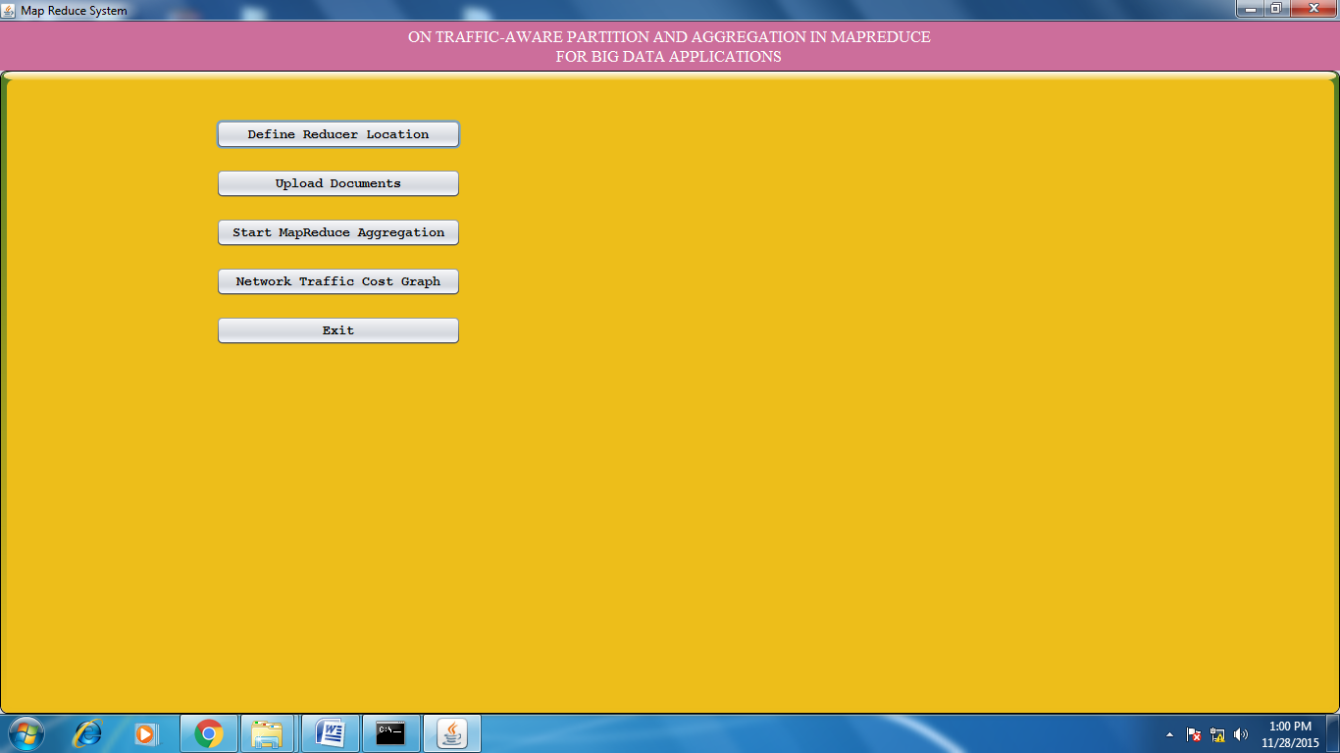

Click on Define Reducer location and add 2 reducer locations.

Defining reducer 1 at certain location. (For location we are taking the latitude and longitude values)

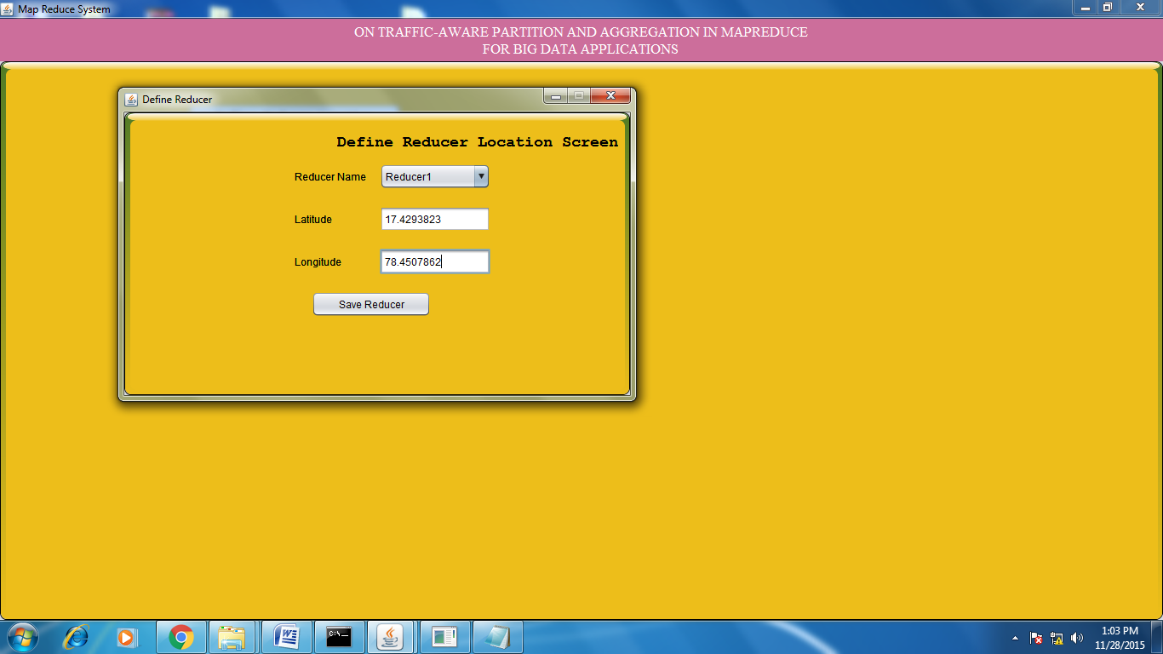

After successfully adding the reducer 1 details:

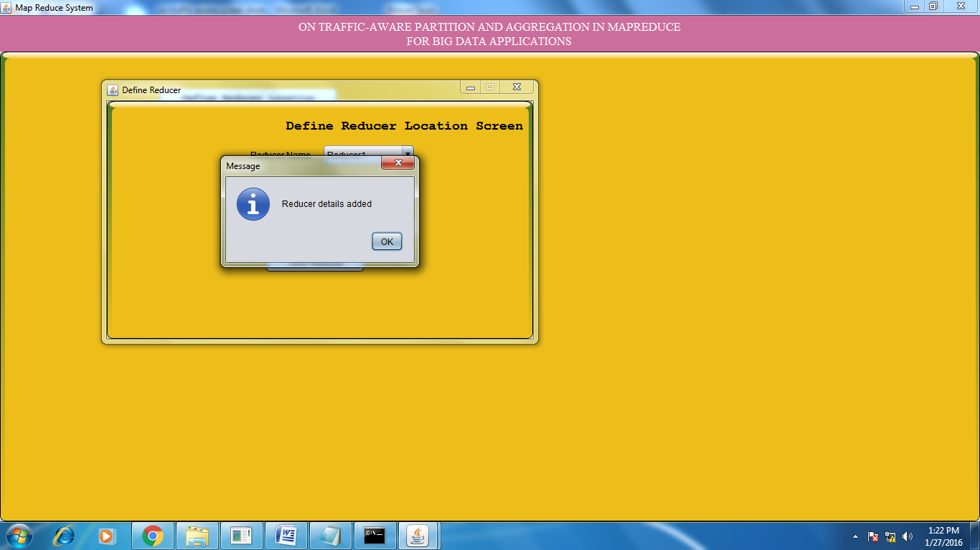

Defining reducer 1 at certain location

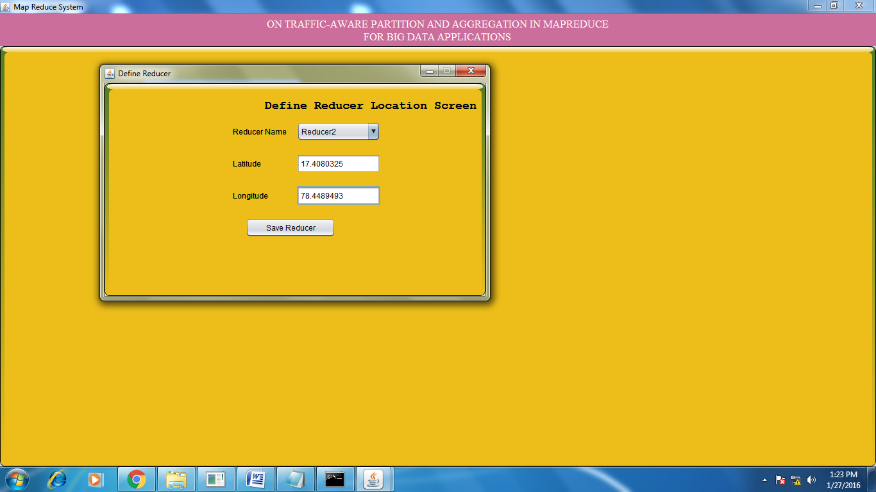

After successfully adding the reducer 2 details:

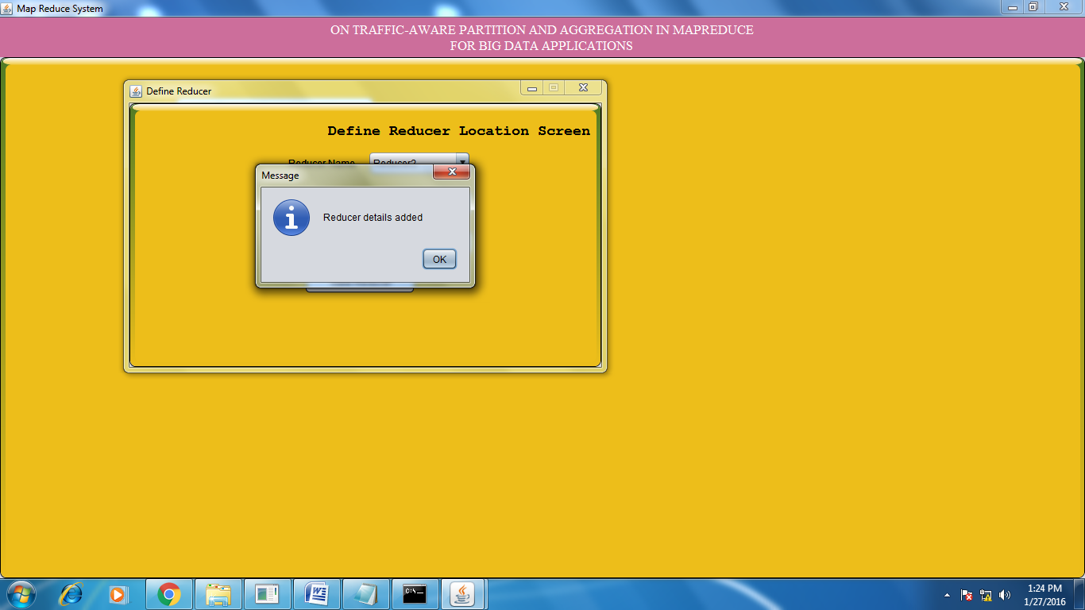

Run the reducer applications (reducer 1 & reducer 2):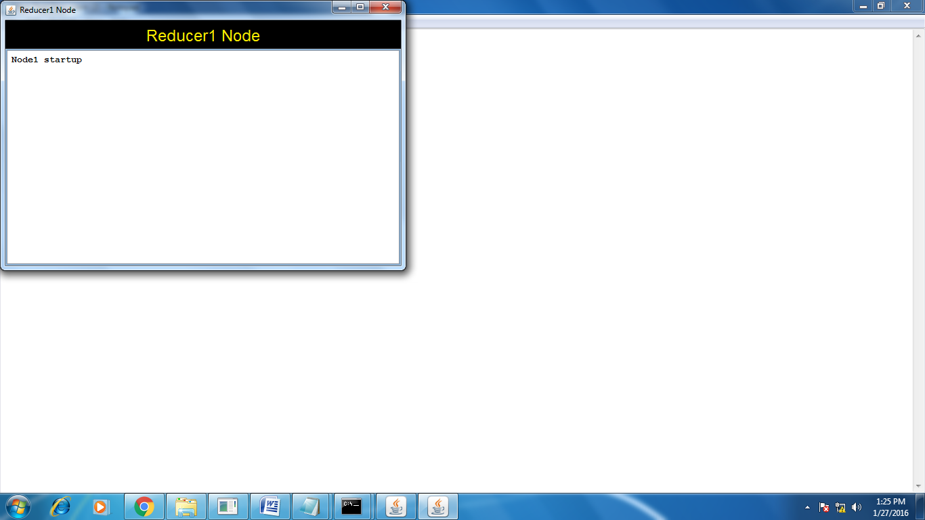 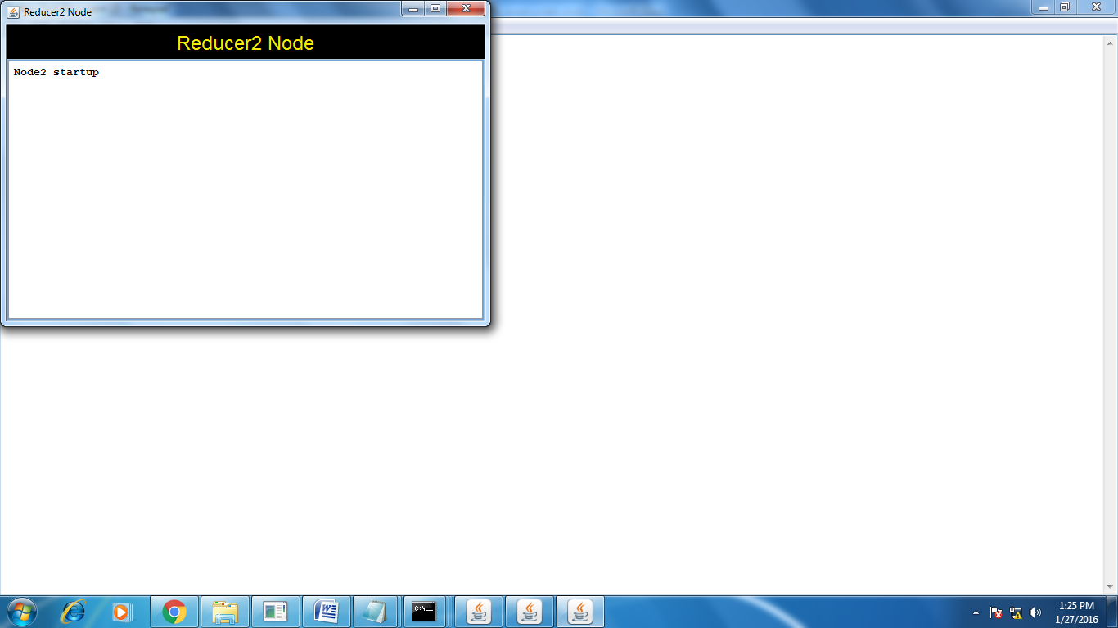

Click on upload documents and upload the input data to our application:

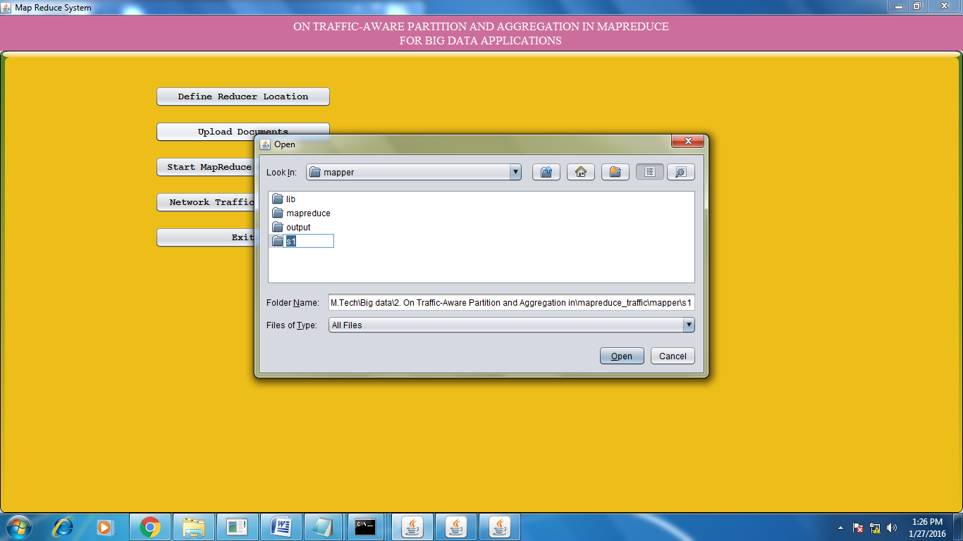

After successfully loading the input data:

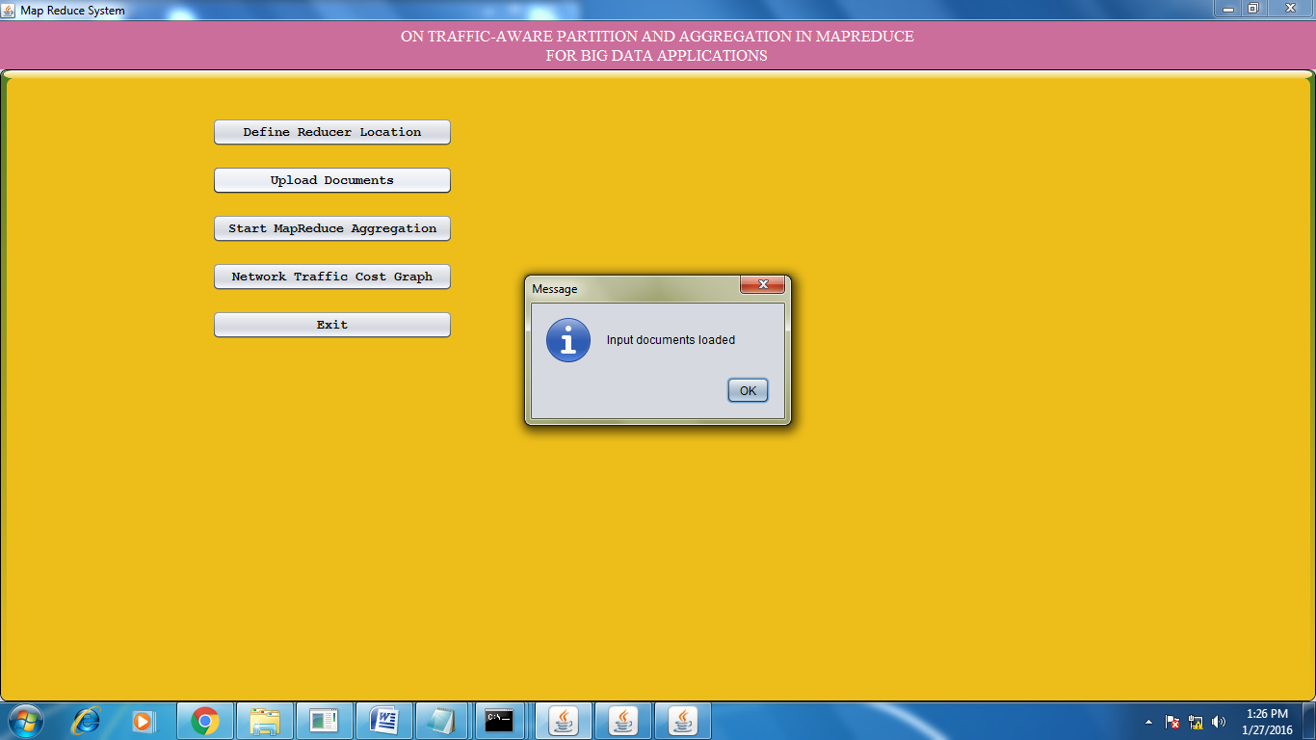

Click on start MapReduce Aggregation:

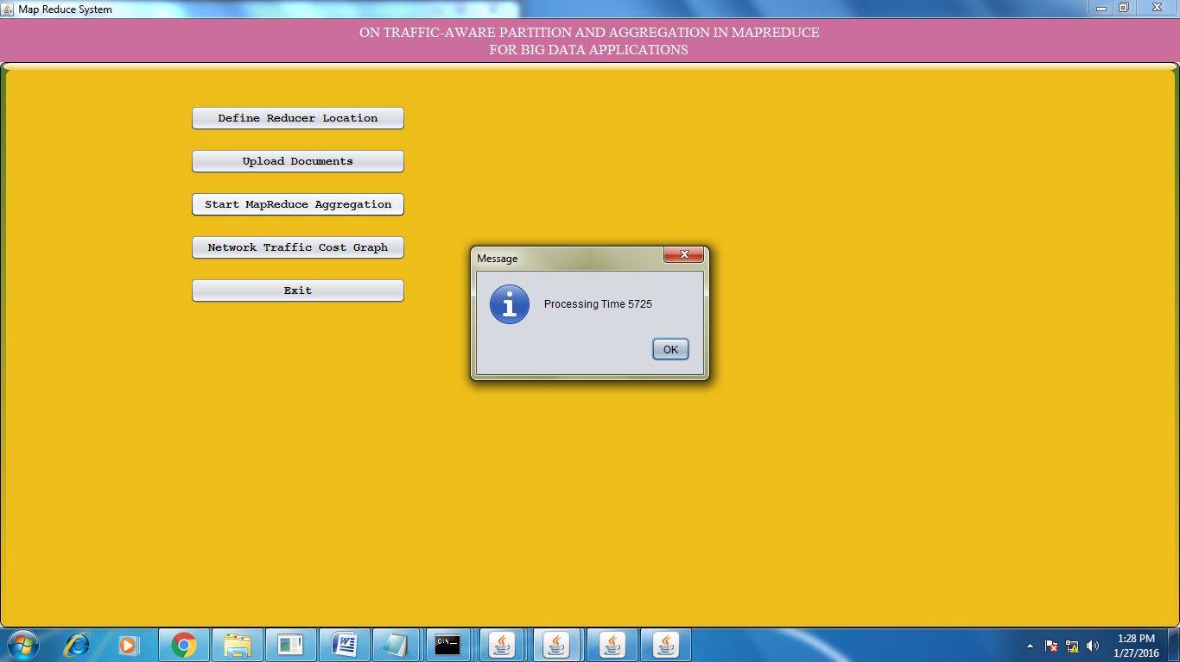

Aggregated data after successfully processing:

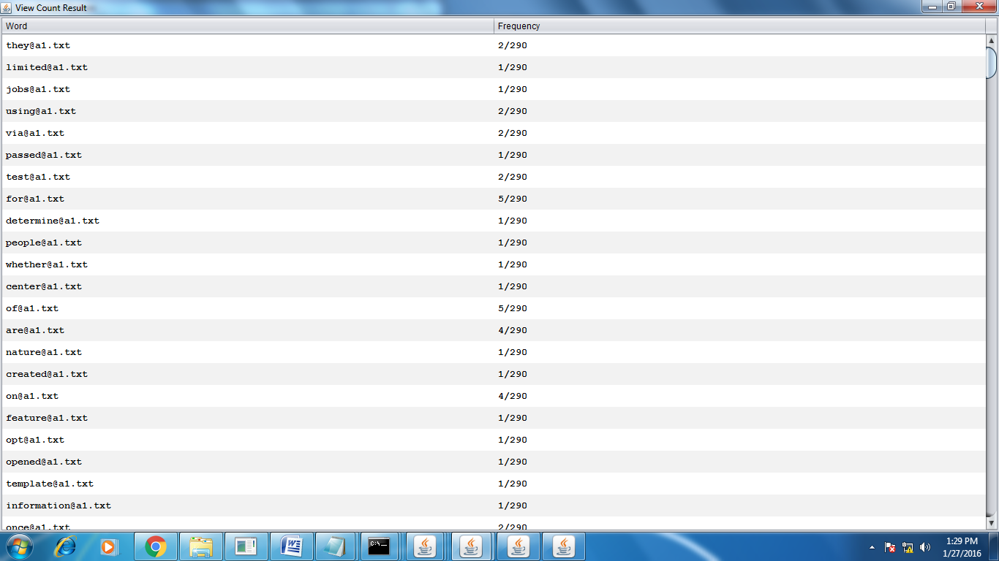

Reducer applications:

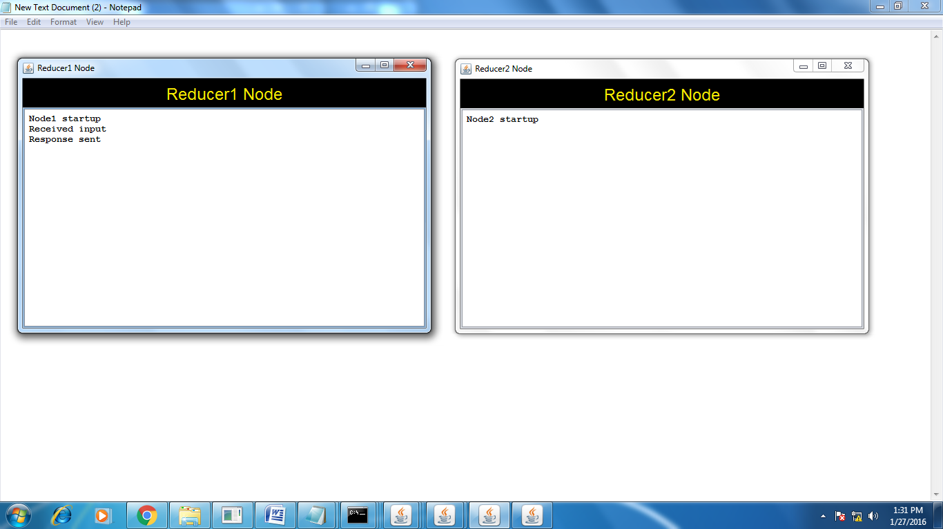

In the above, the request has been processed by Reducer 1, because the reducer 1 is nearer to the mapper location . (for mapper application location details refer Main.java line number 214)

Click on network traffic cost graph:

